4.1

a) 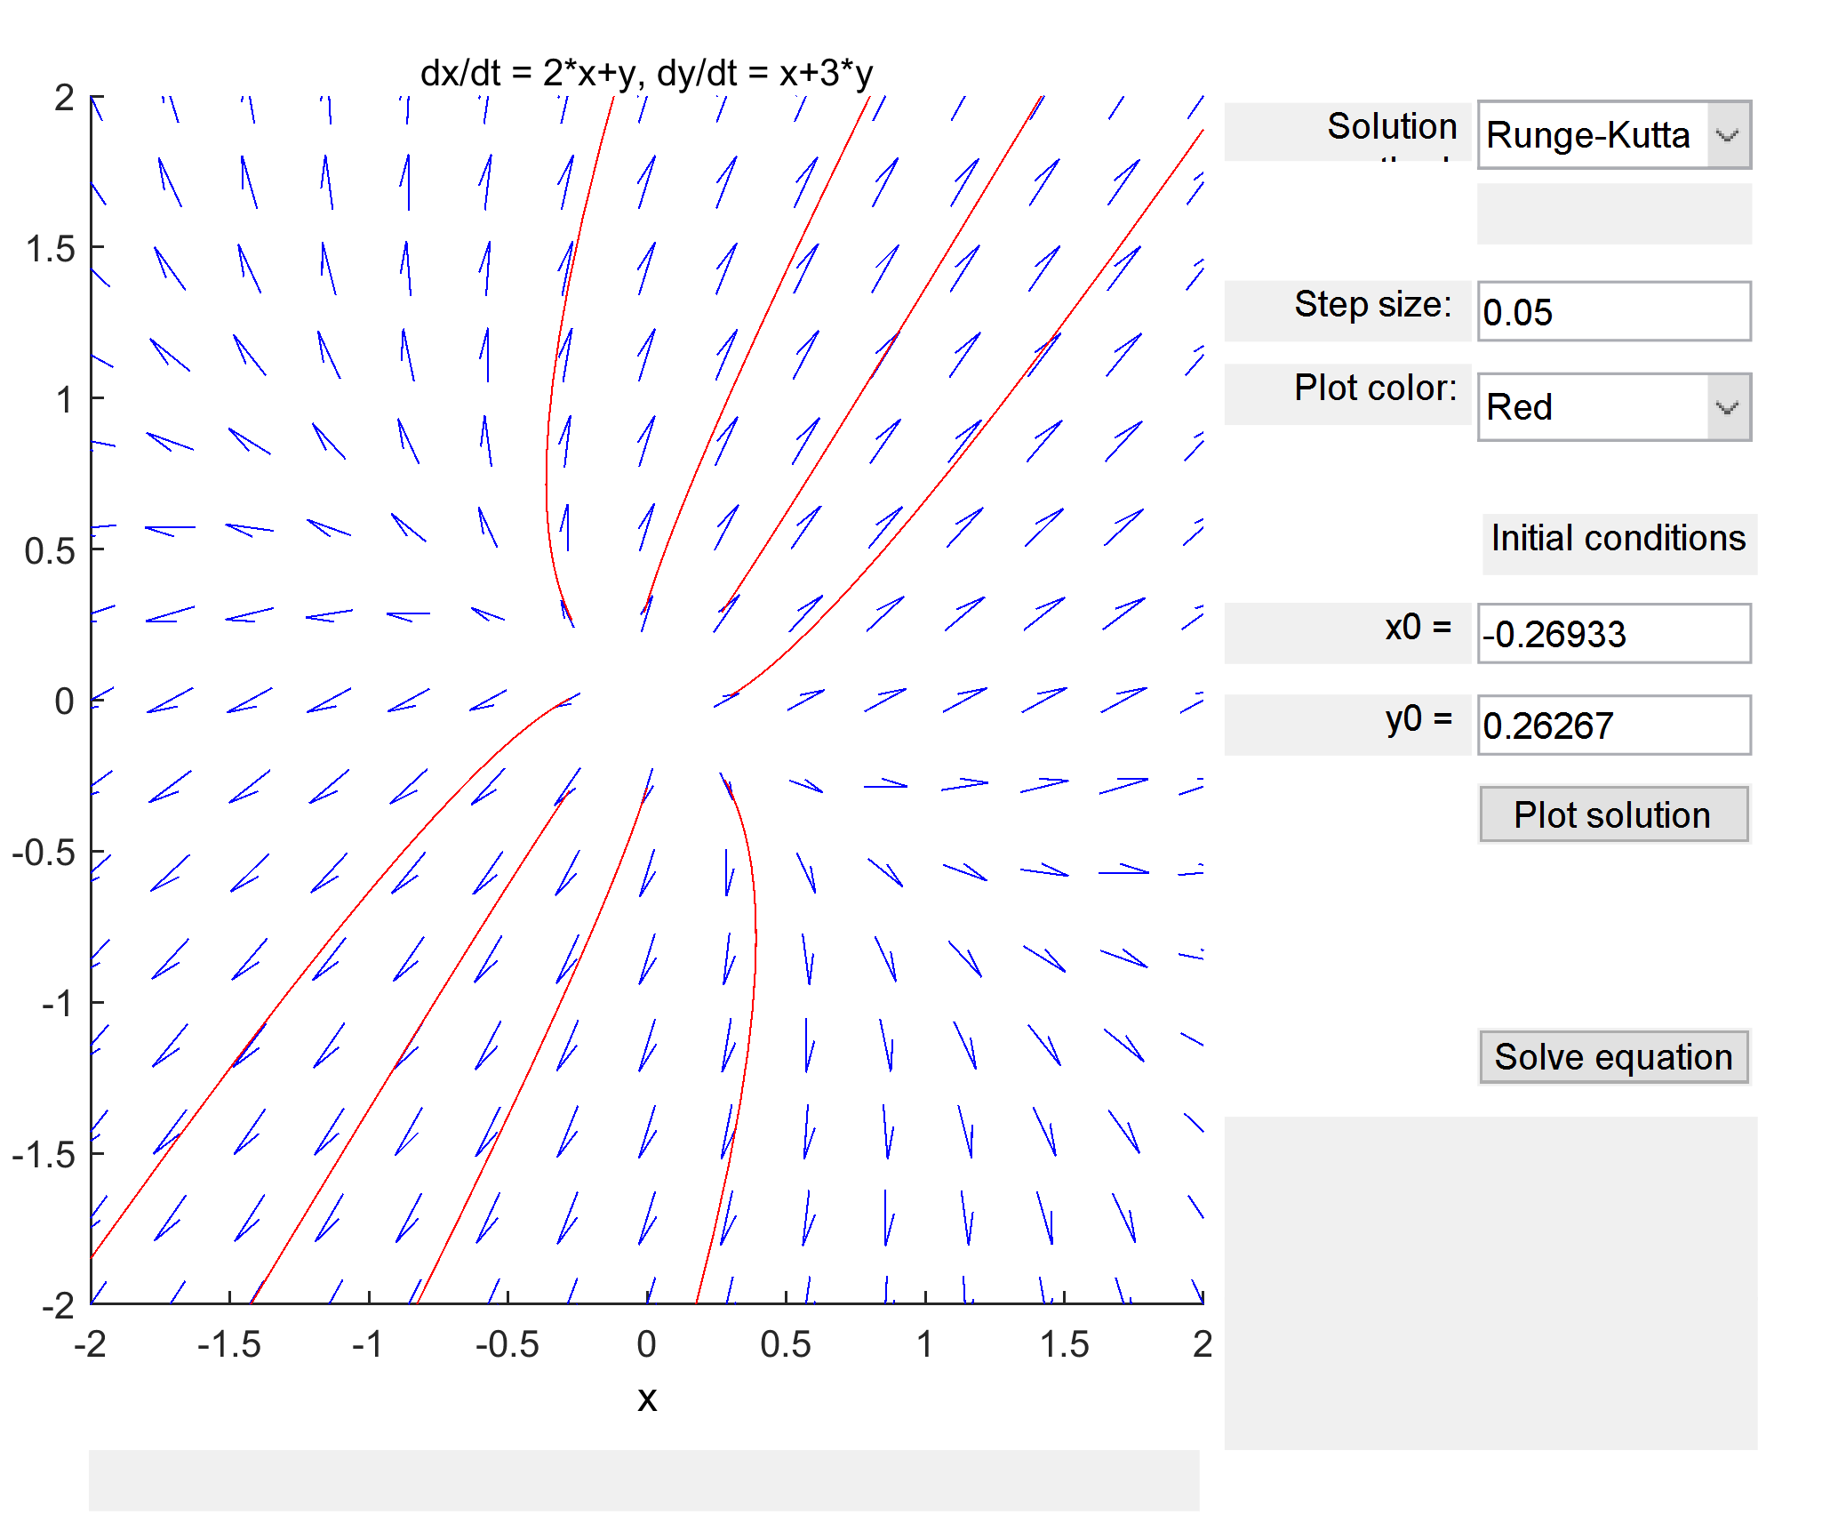

b) Nodal source, unstable

c)

NOTE:

For the phase portrait, the trajectory matched the expected behavior as determined by the eigenvalues.

(case: two positive real eigenvalues mean unstable nodal source)

4.2

a) 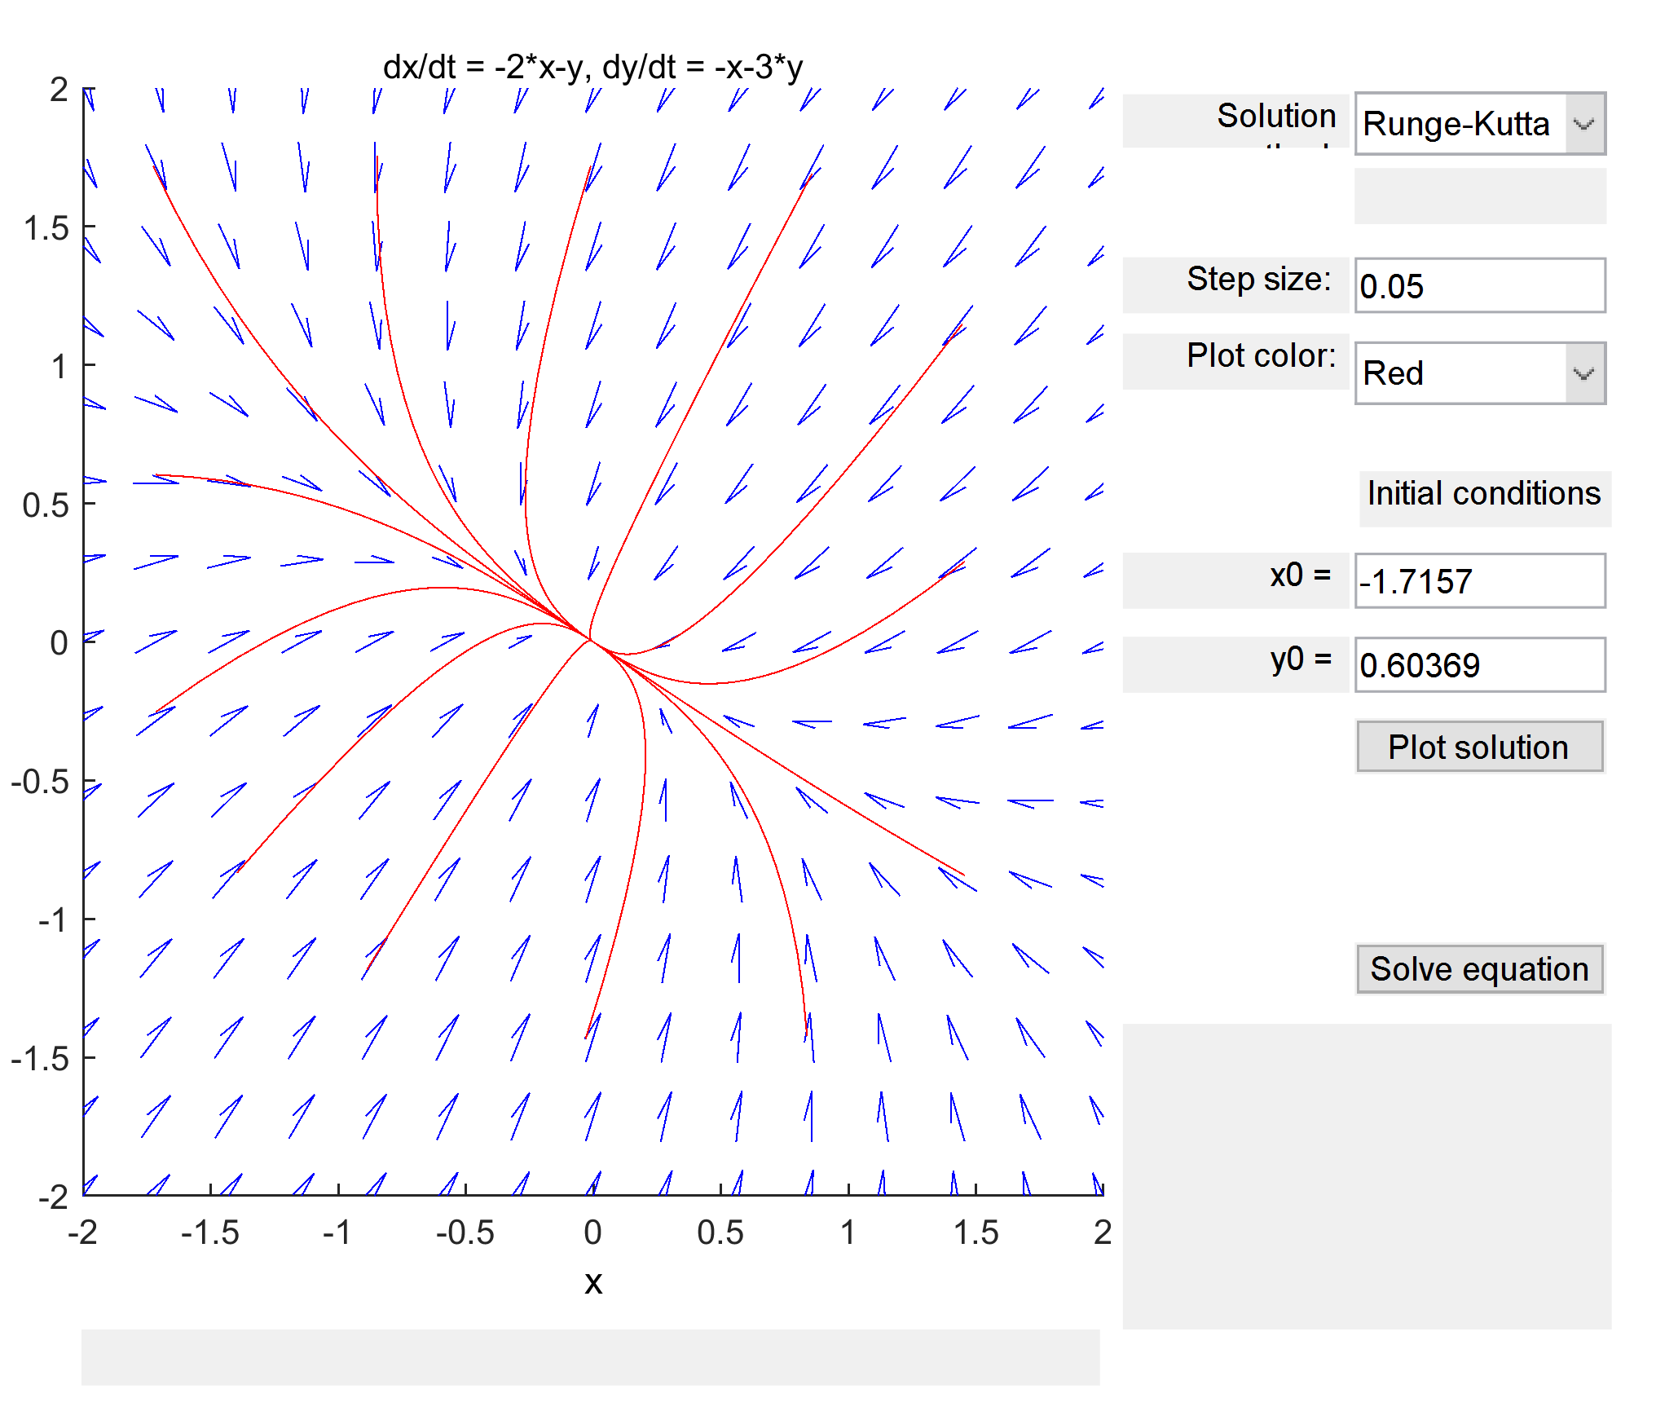

b) Nodal sink, asymptotically stable

c)

NOTE:

For the phase portrait, the trajectory matched the expected behavior as determined by the eigenvalues.

(case: two negative real eigenvalues mean asymptotically stable nodal sink)

4.3

a) 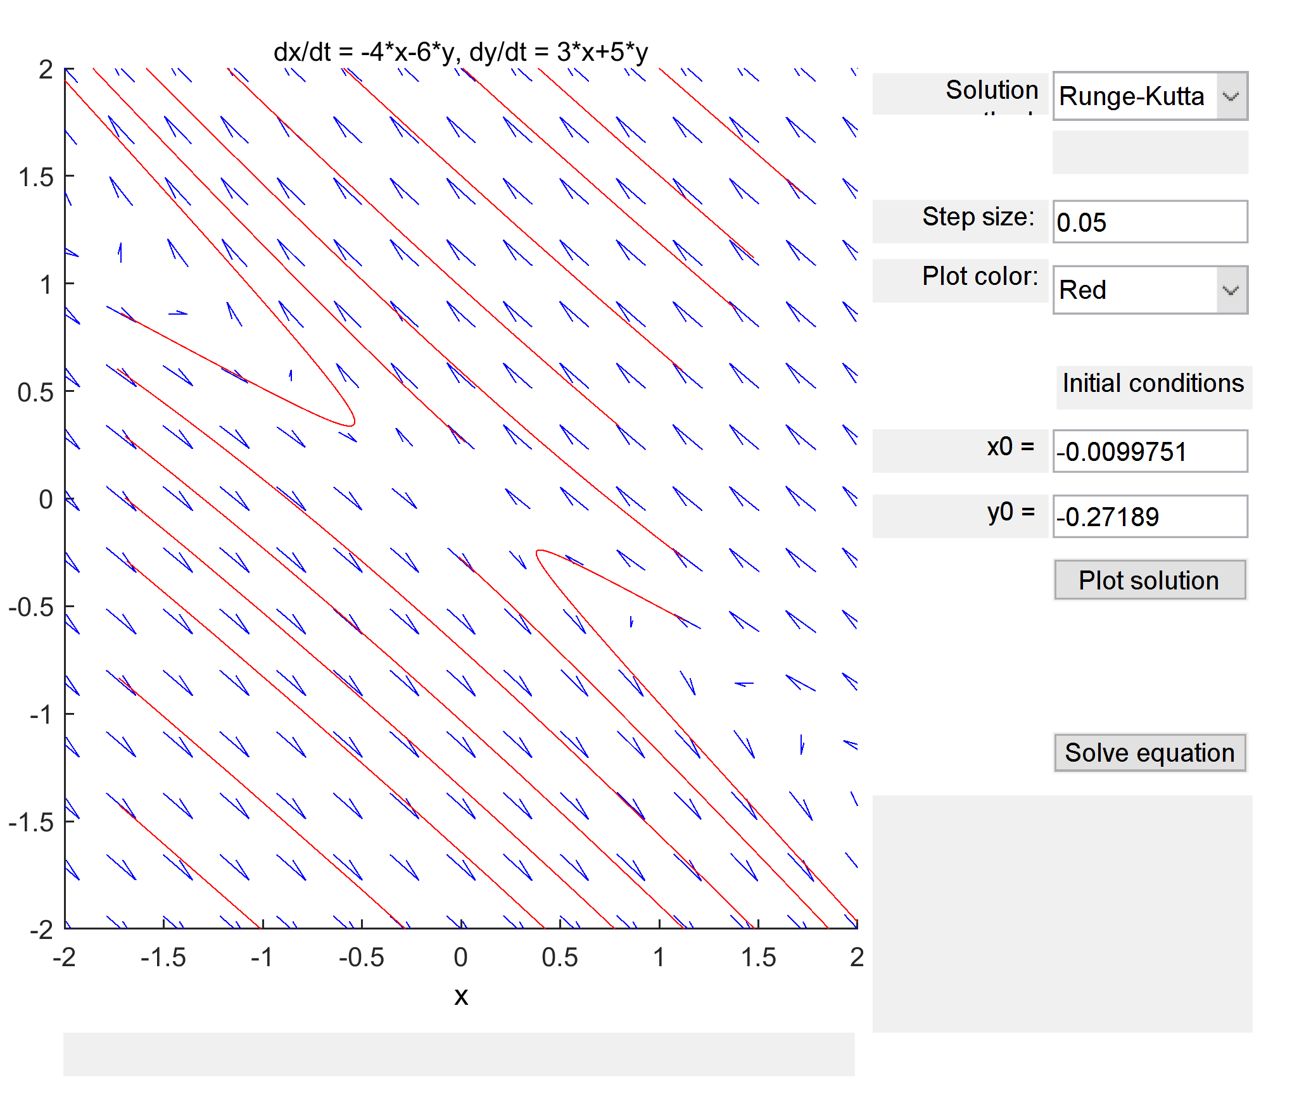

b) Saddle point, unstable

c)

NOTE:

For the phase portrait, the trajectory matched the expected behavior as determined by the eigenvalues.

(case: one positive, one negative real eigenvalues mean unstable saddle point)

4.4

a) 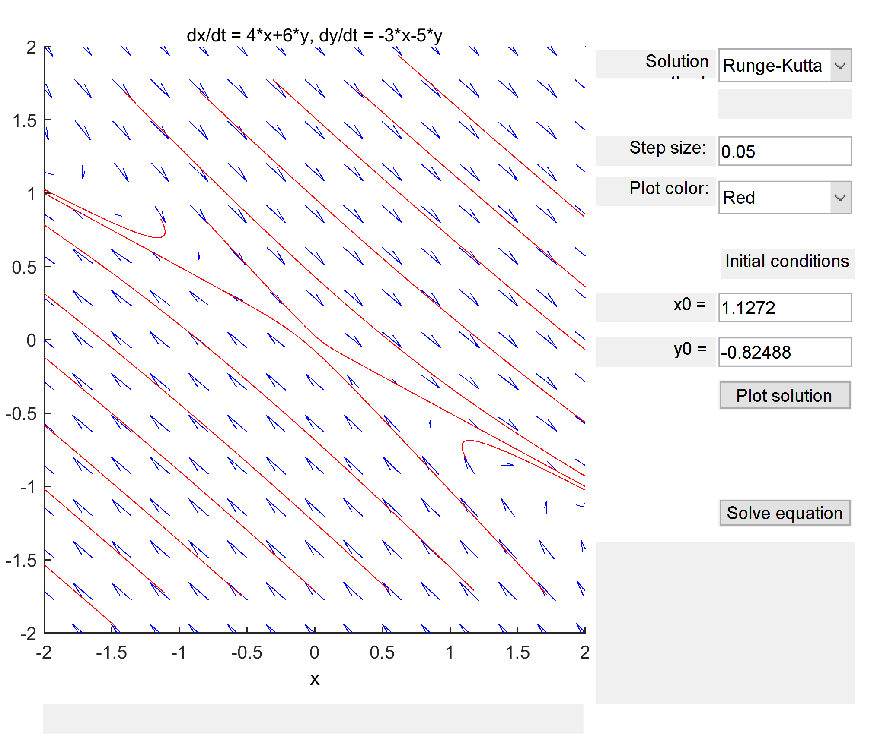

b) Saddle point, unstable

c)

NOTE:

For the phase portrait, the trajectory matched the expected behavior as determined by the eigenvalues.

(case: one positive, one negative real eigenvalues mean unstable saddle point)

4.5

a) 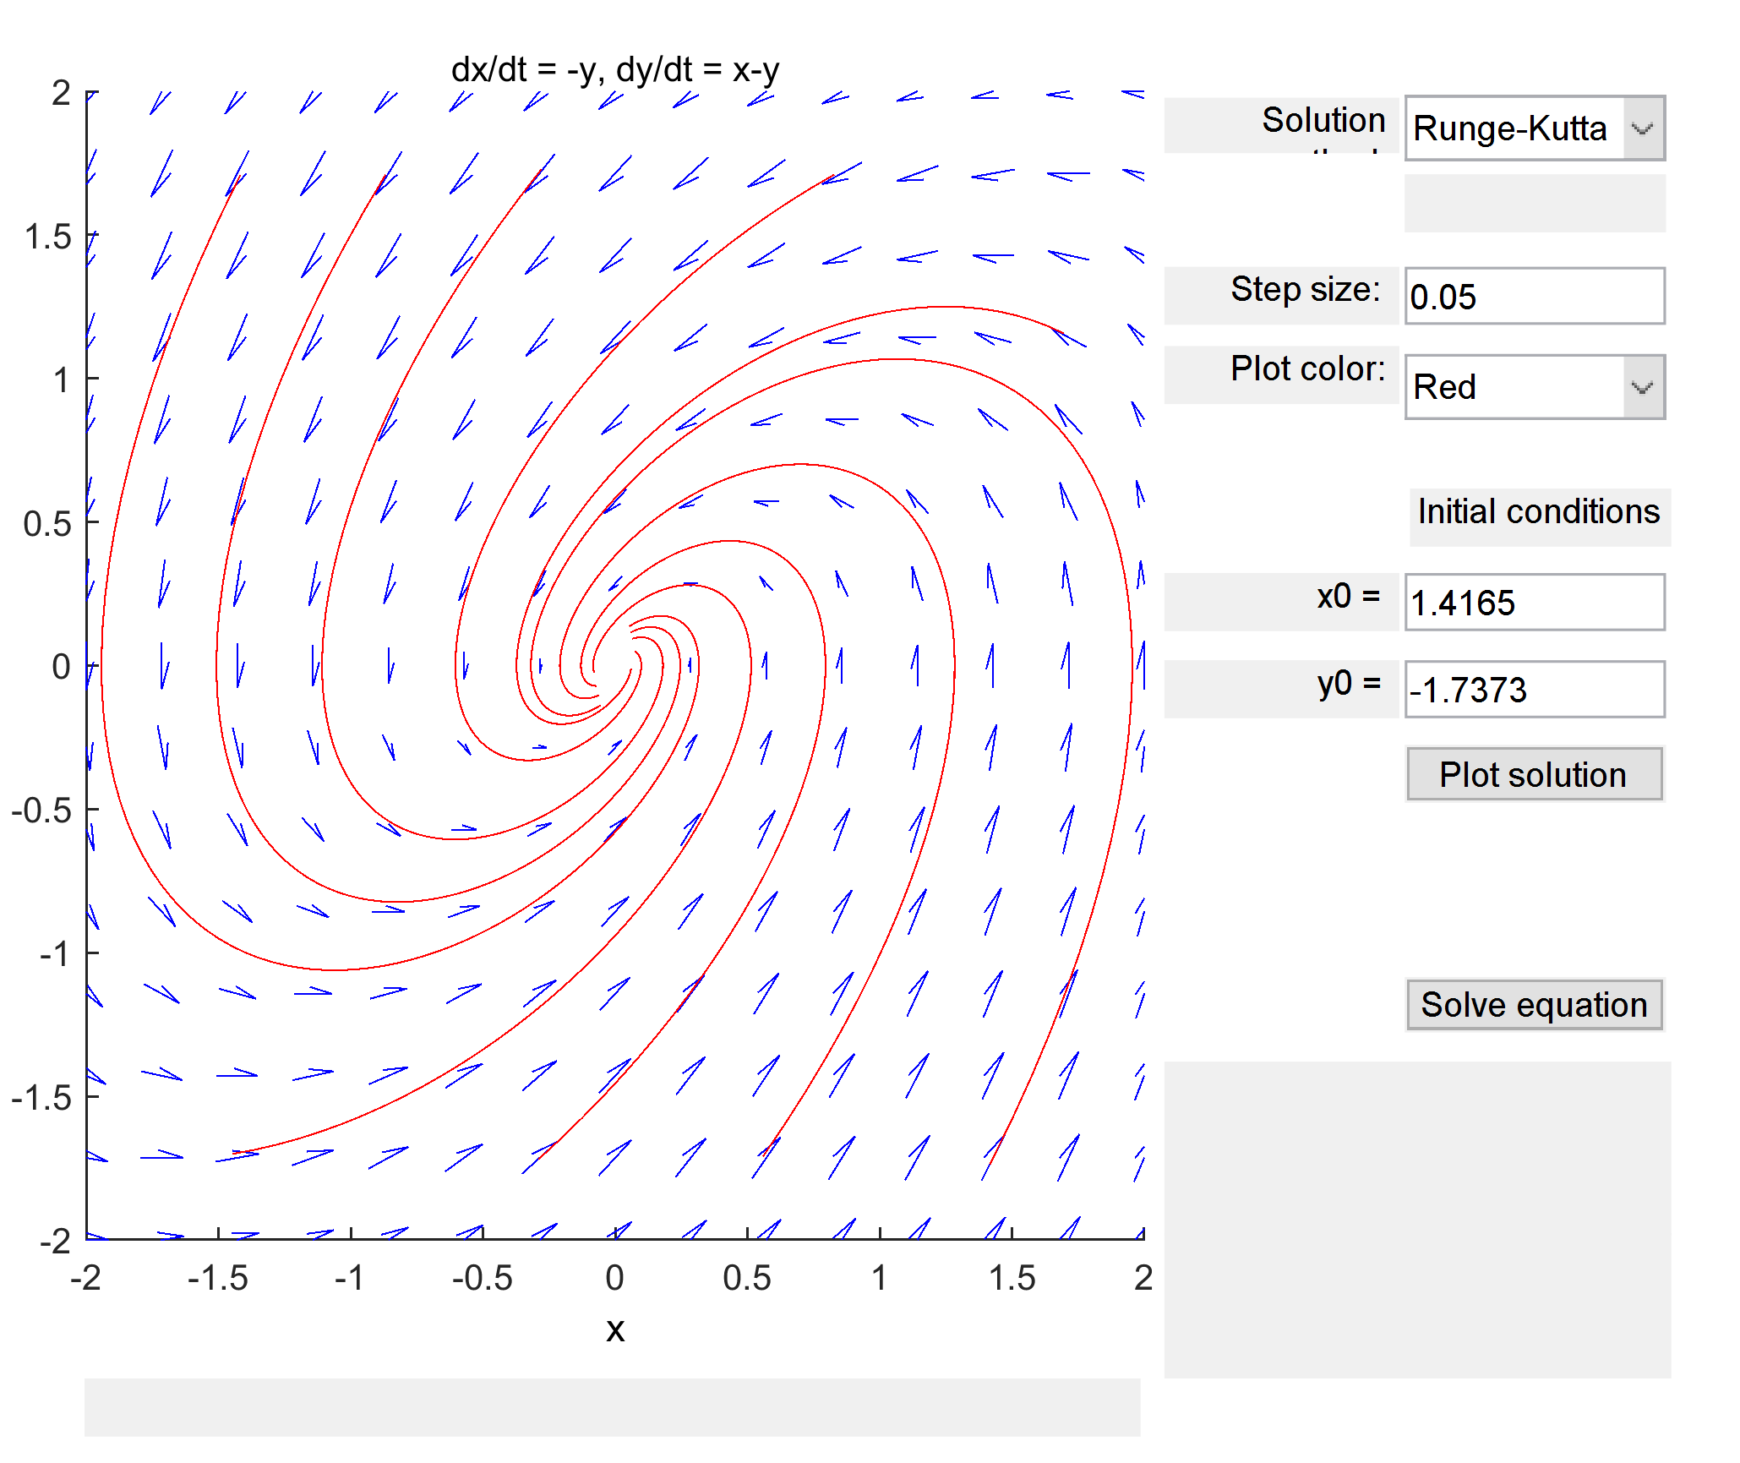

b) Counterclockwise spiral sink, asymptotically stable

c)

NOTE:

For the phase portrait, the trajectory matched the expected behavior as determined by the eigenvalues.

(case: two complex eigenvalues with negative real component mean asymptotically stable spiral sink)

4.6

a) 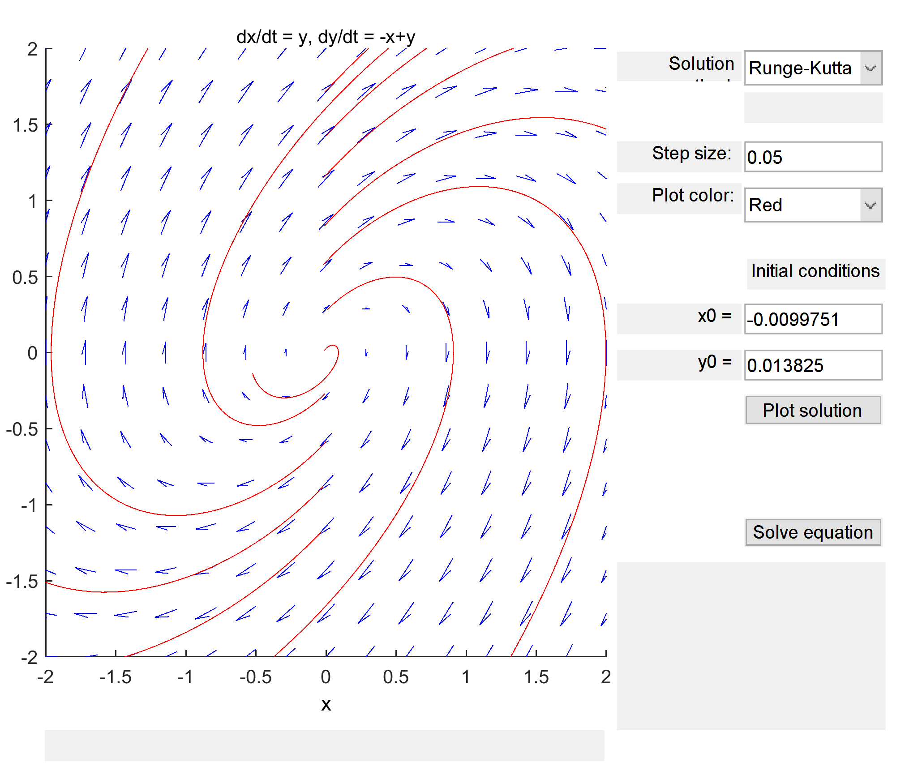

b) Clockwise spiral source, unstable

c)

NOTE:

For the phase portrait, the trajectory matched the expected behavior as determined by the eigenvalues.

(case: two complex eigenvalues with positive real component mean unstable spiral source)

4.7

a) 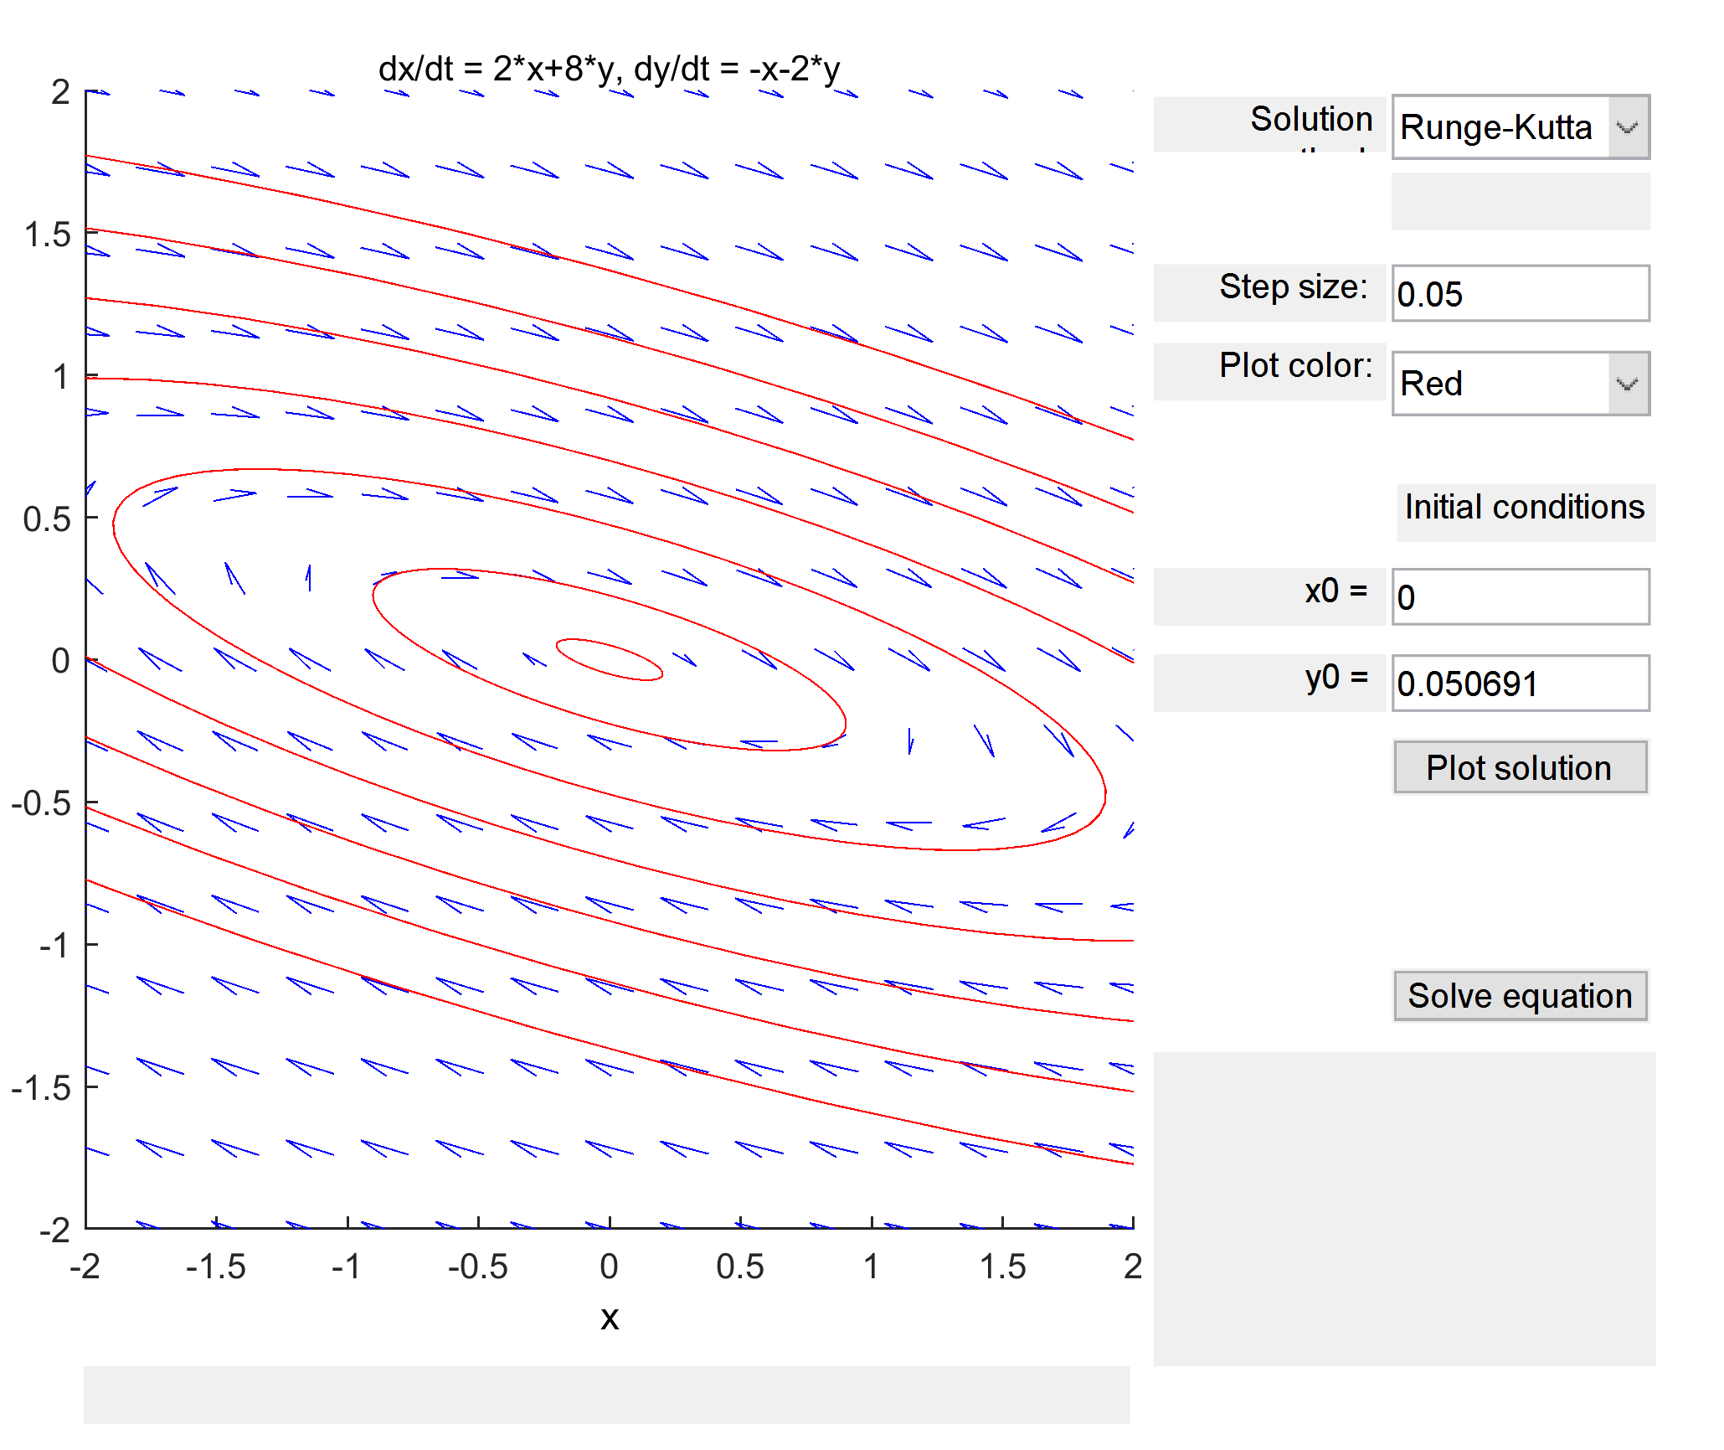

b) Clockwise centre, stable

c)

NOTE:

For the phase portrait, the trajectory matched the expected behavior as determined by the eigenvalues.

(case: two complex eigenvalues with no real component mean stable centre)

4.8

a) 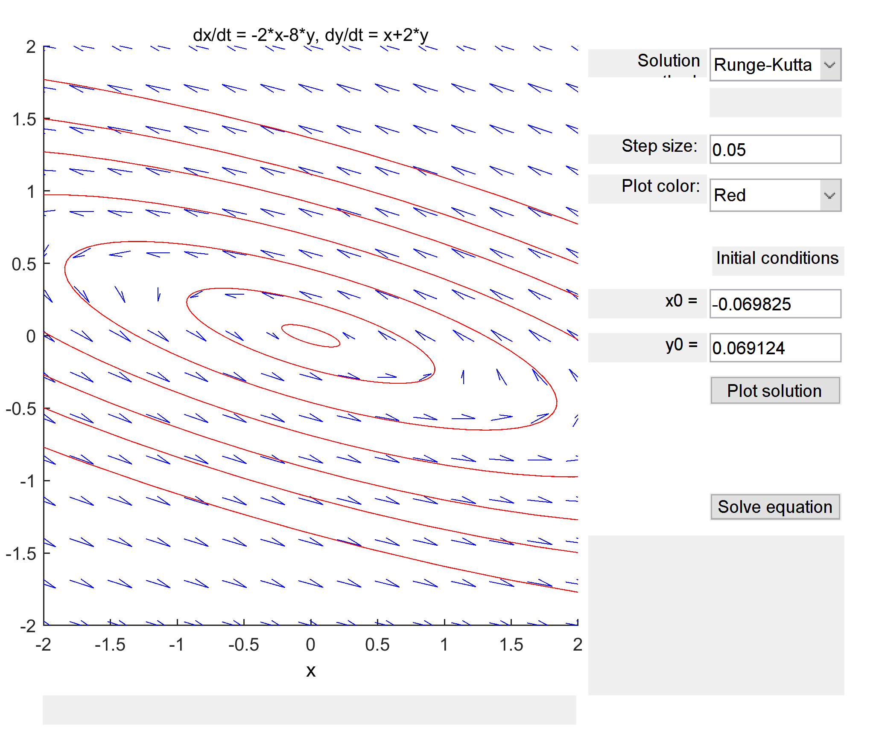

b) Counterclockwise centre, stable

c)

NOTE:

For the phase portrait, the trajectory matched the expected behavior as determined by the eigenvalues.

(case: two complex eigenvalues with no real component mean stable centre)

4.9

a) 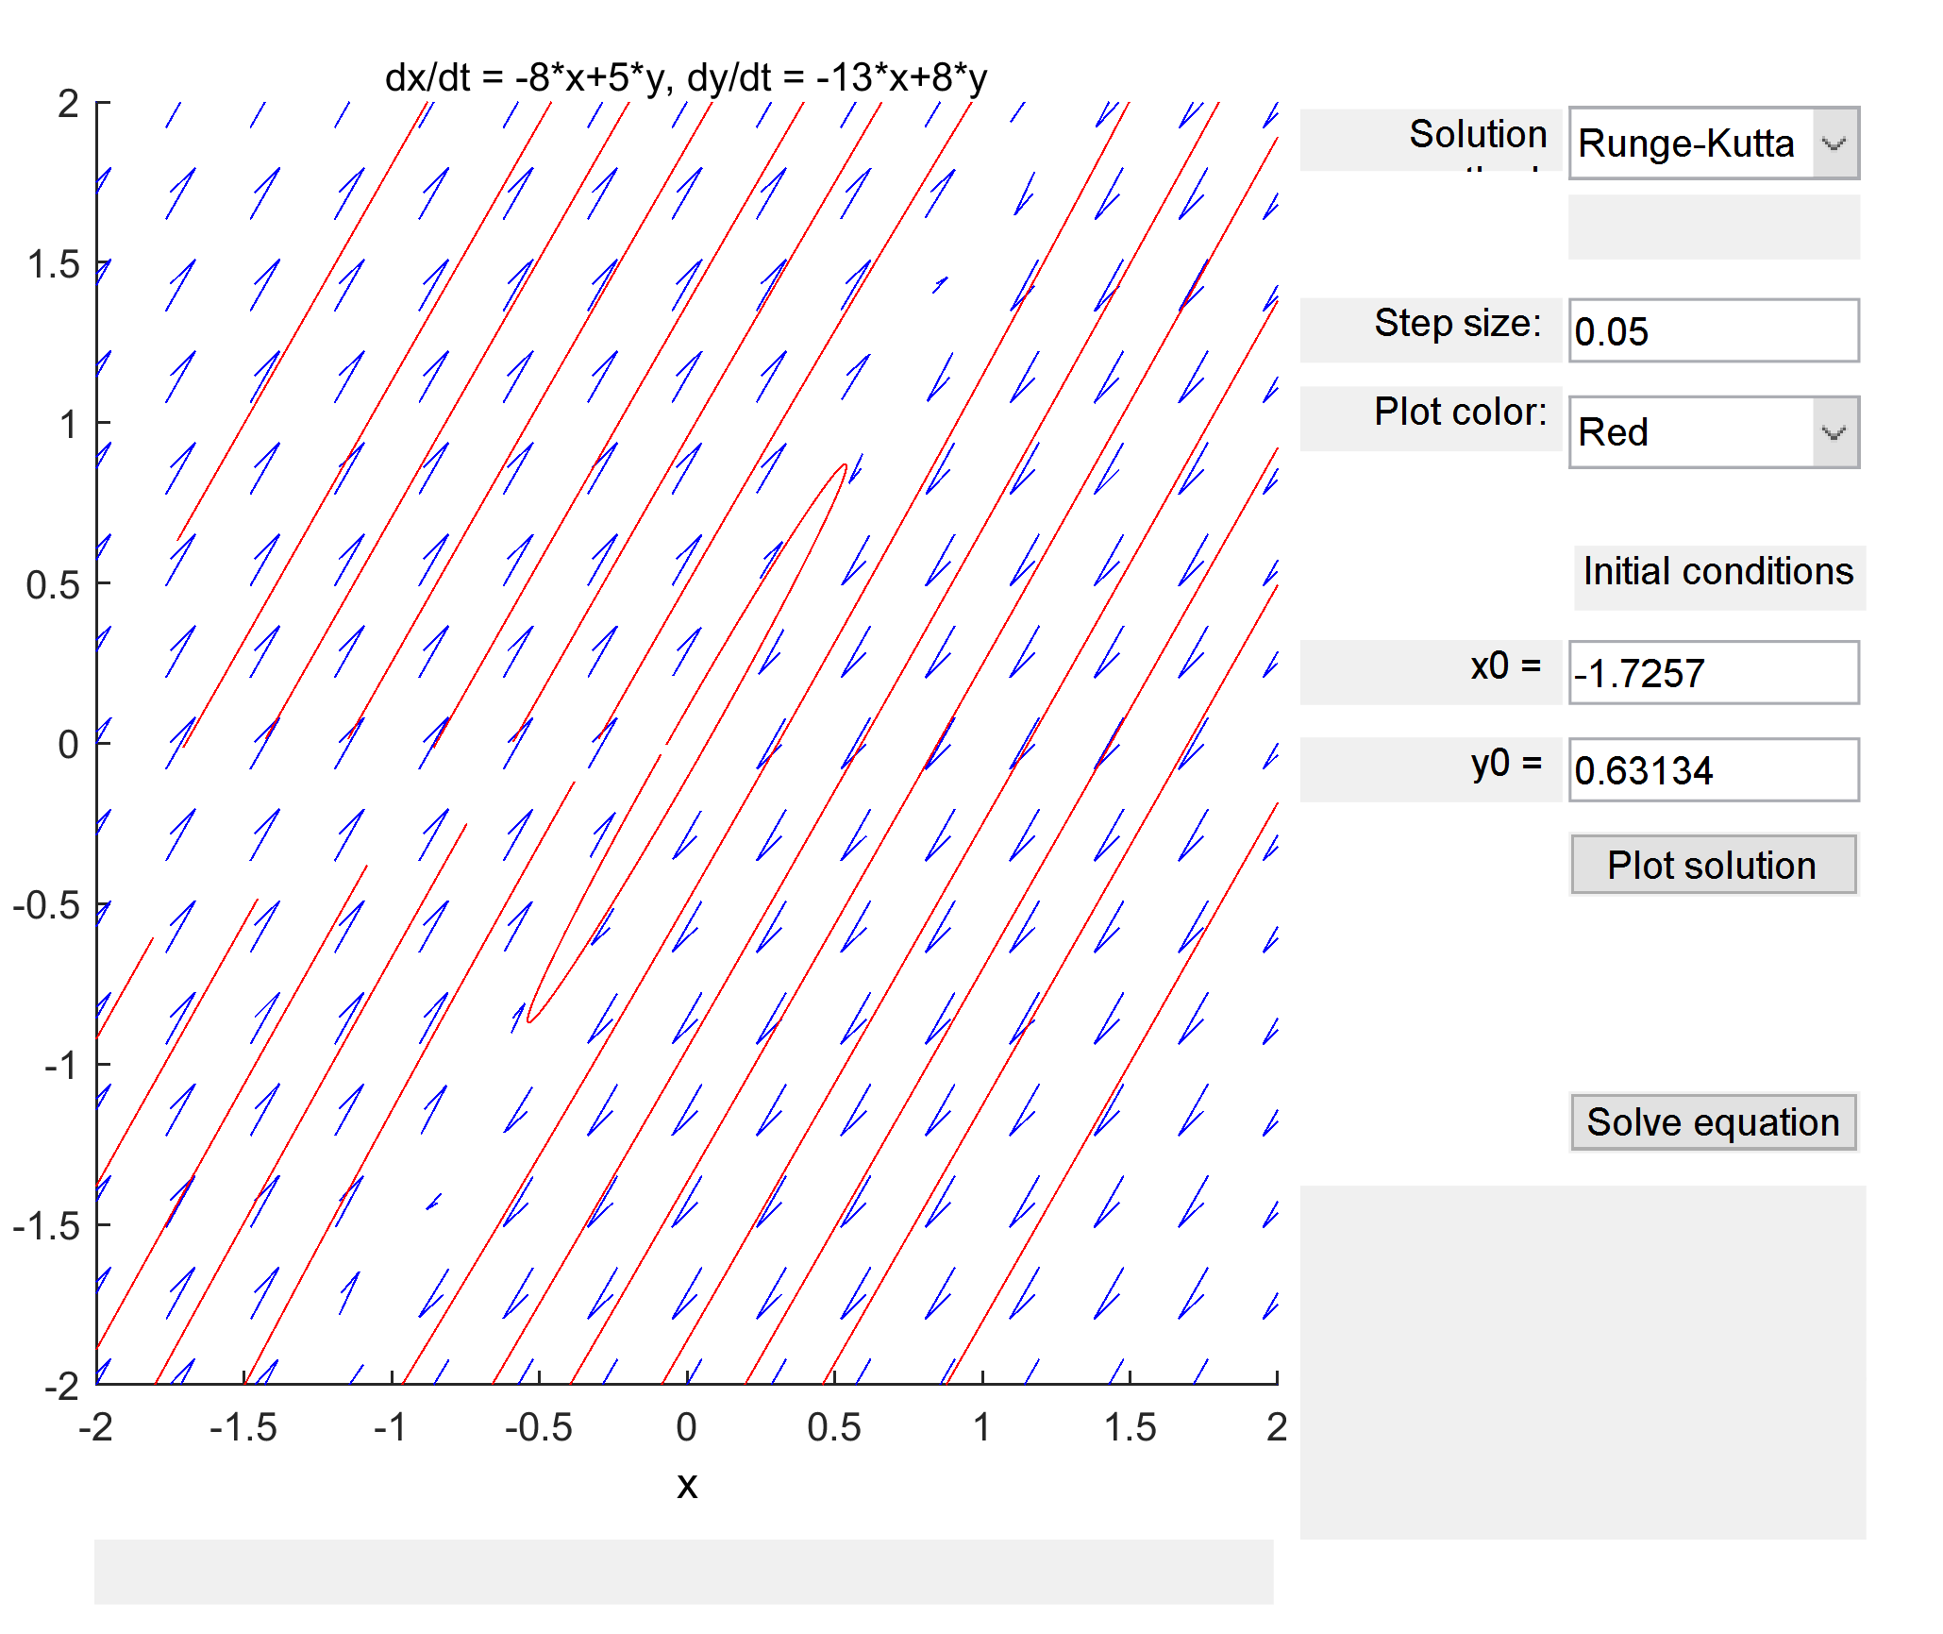

b) Clockwise centre, stable

c)

NOTE:

For the phase portrait, the trajectory matched the expected behavior as determined by the eigenvalues.

(case: two complex eigenvalues with no real component mean stable centre)

4.10

a) 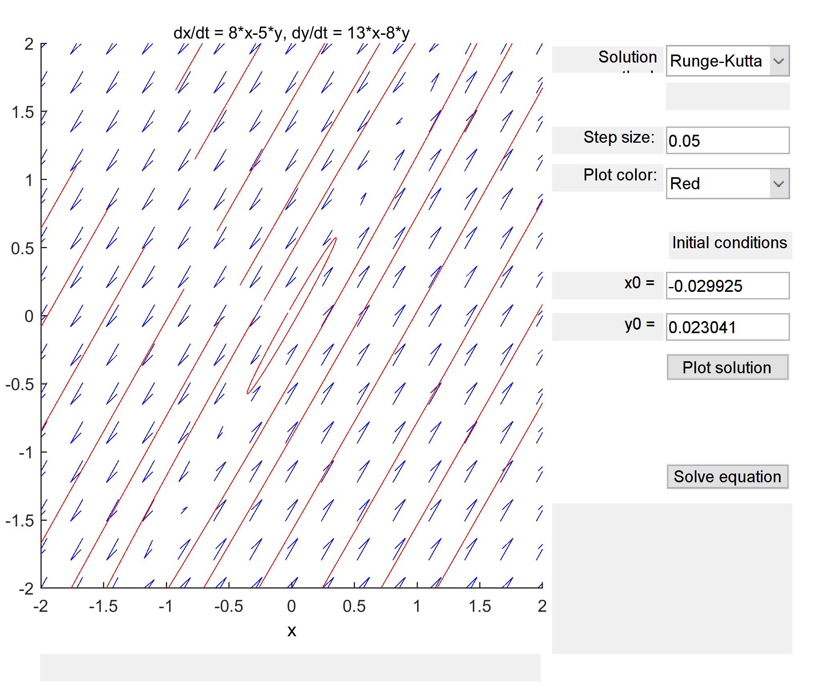

b) Counterclockwise centre, stable

c)

NOTE:

For the phase portrait, the trajectory matched the expected behavior as determined by the eigenvalues.

(case: two complex eigenvalues with no real component mean stable centre)